**Question - 01:**

Calculate the Product of two numbers WITHOUT using the * operator.

**Question - 02:**

The factorial of a positive number n is given by:

factorial of n (n!) = 1*2*3*4....n  
The factorial of a negative number doesn't exist. And, the factorial of 0 is 1, 0! = 1

**Question - 03:**

Create a program that takes an integer from the user and calculates the number of digits. For example: If the user enters 2319, the output of the program will be 4.

**Question - 04:**

The Fibonacci sequence is a series where the next term is the sum of pervious two terms. The first two terms of the Fibonacci sequence is 0 followed by 1.

The Fibonacci sequence: 0, 1, 1, 2, 3, 5, 8, 13, 21

Create a program to generate a Fibonacci Series of N numbers.

**Question - 05:**

Draw the following ex pattern, program should take a command-line argument N and print pattern program of stars and alphabets:

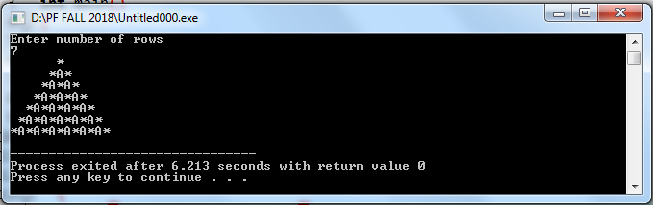

**Question - 06:**

Draw the following ex pattern, program should take a command-line argument N and print the following pattern.

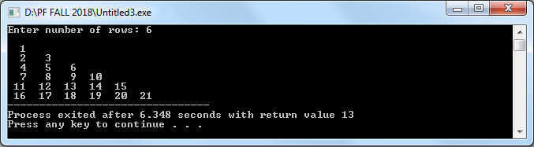

**Question - 07:**

Create a program takes a positive integer from the user and displays all the positive factors of that number.

**Home Work:**

Draw the following ex pattern, program should take a command-line argument N and prints a (2N + 1)-by-(2N + 1) like the one below. Hint: Use two for loops and one if-else statement.

